Fuhai Met Mast O&M record 2020

O&M Works in 2020
The Acoustic Doppler Current Profiler (ADCP) and Salt Temperature Depth Device (CTD) were recovered. The former decided to recover it for inspection first because the accuracy of the data return was too low, while the latter decided to recover it from the seabed and bring it back for the onshore testing because of communication failure. It is speculated that the damage was caused by marine debris.

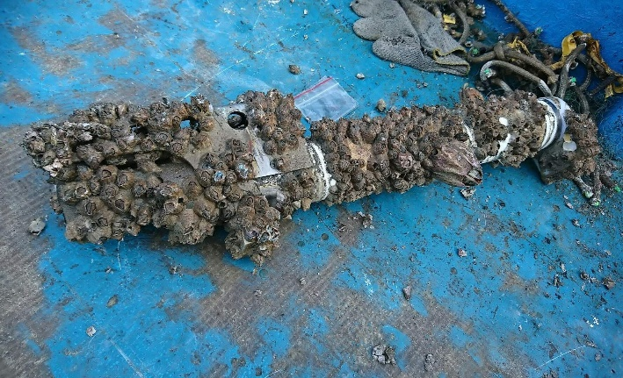

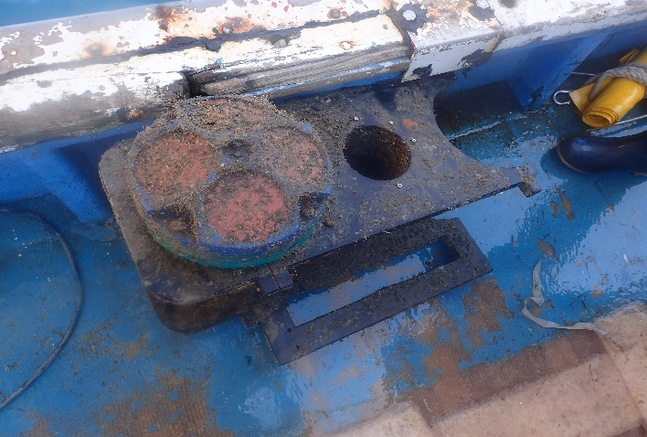

CTD and ADCP recovered from the seabed

Carry out GPS coordinate measurement of the Met Mast and water depth measurement within the structure.
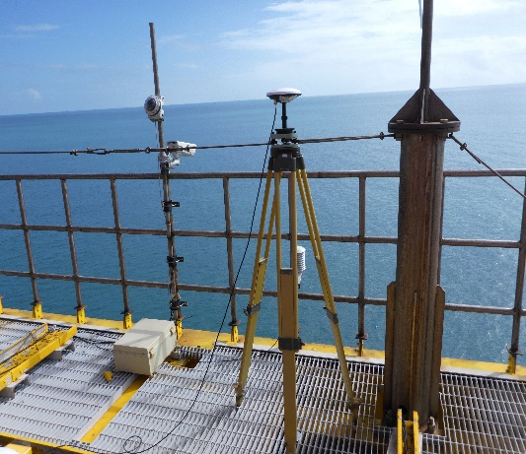
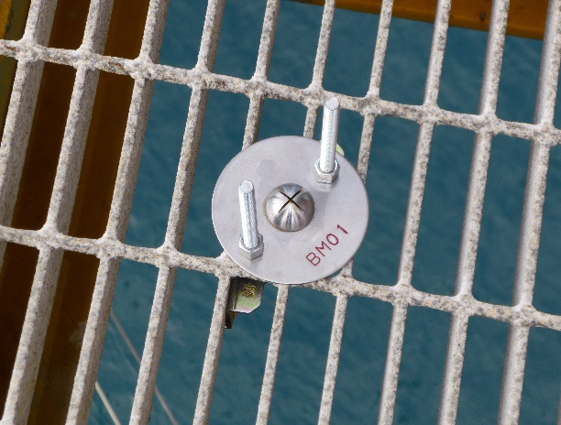
After establishing the reference point, we set up the GPS positioning measuring instrument.

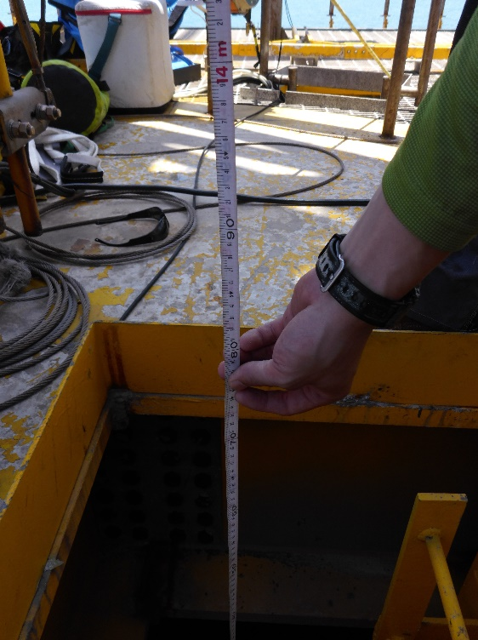
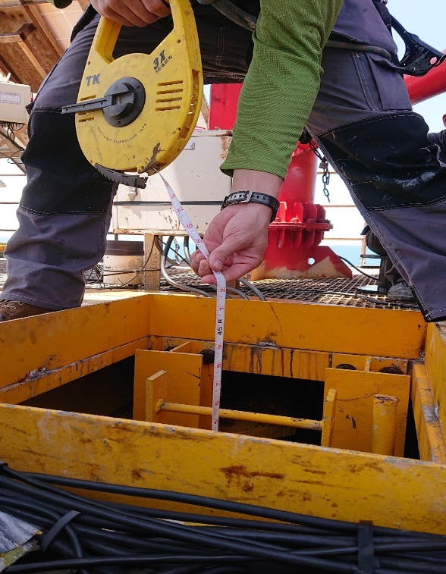
Use a water level tape measure to measure the water level inside the structure

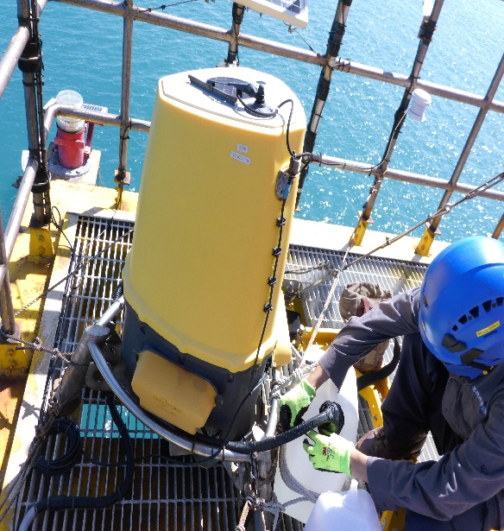
Regular maintenance of LiDAR and solar power panels, and replacement of navigation warning lights.
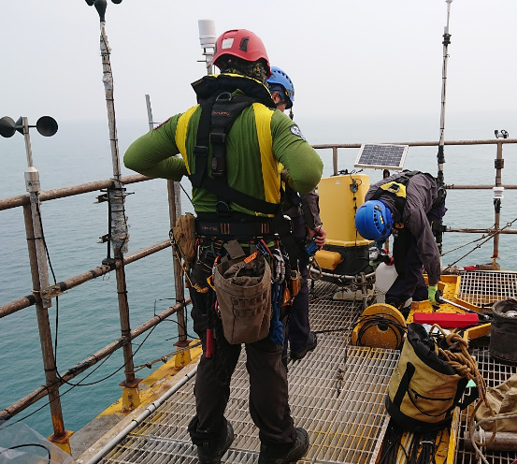

LiDAR cleaning and maintenance

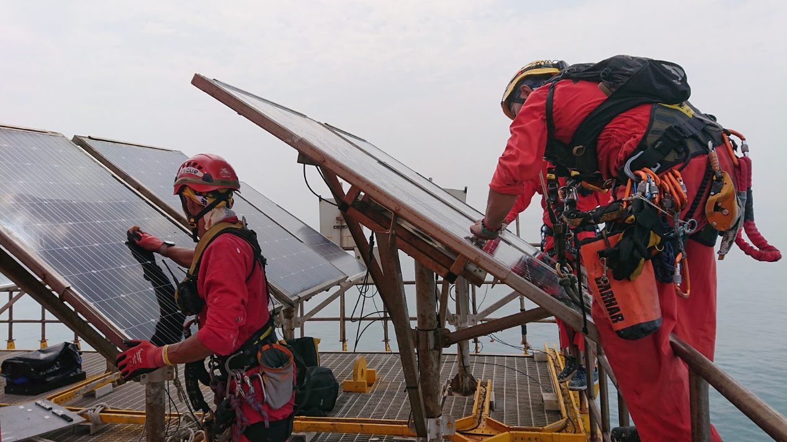
Solar panel cleaning and maintenance

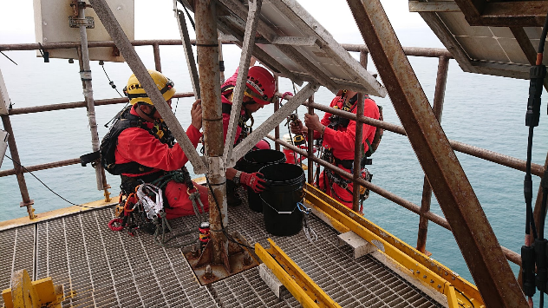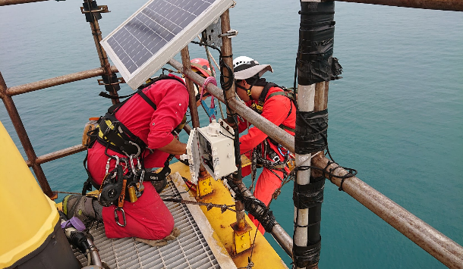
Marine warning light replacement

